**UML Class Diagrams**

**for the**

**SIUE Department of Computer Science**

**CS425 / CS499 Senior Project**

**Software Design and Implementation Courses**

**by**

**Zach Benchley, Matt Lievens, Logan Maughan, Brian Olsen**

**of**



**Learning Outcomes-Based Assessment Database Team**

Revision 1.0

As Of: December 3, 2013

Change Log:

|  |  |
| --- | --- |
| Revision | Change Note(s) |
|  |  |
| 1.0 | * Initial Release |

Reviewed and Approved By:

Name Signature Date

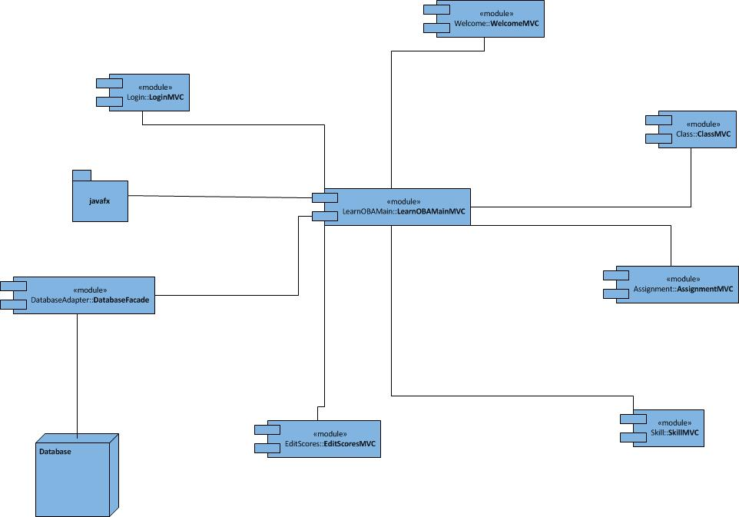

Figure - Component Overview

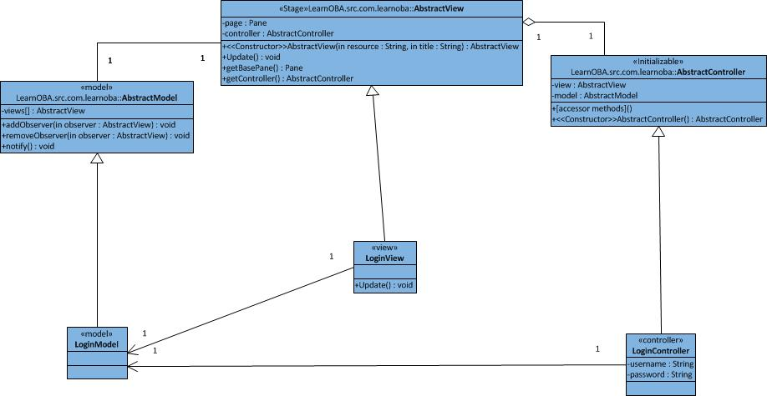

Figure - Login Model View Controller

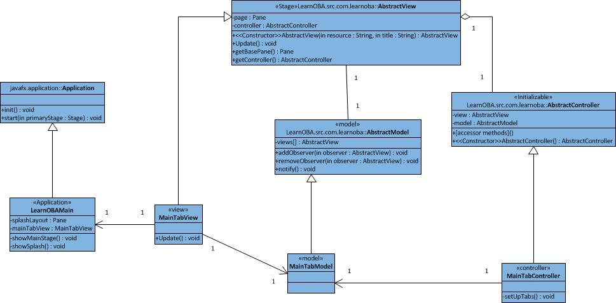

Figure - LearnOBAMain & MainTab Model View Controller

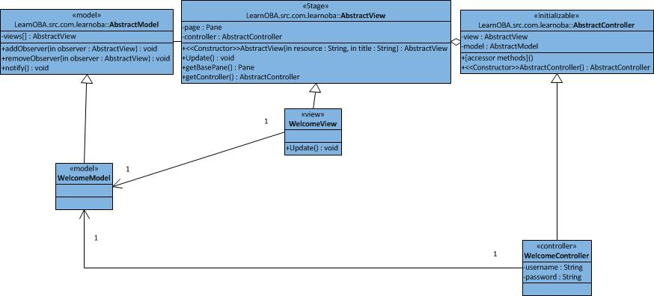

Figure - Welcome Model View Controller

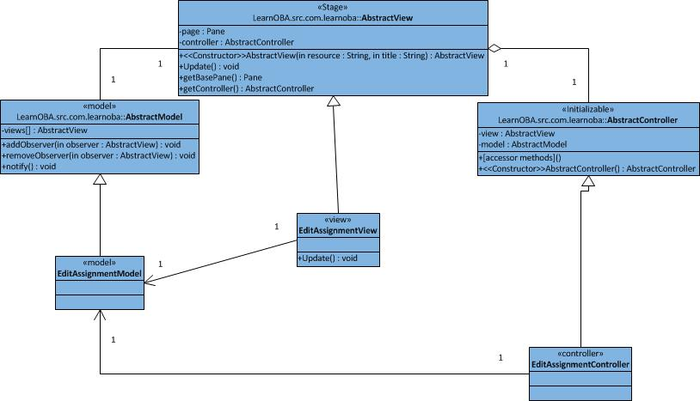

Figure - Edit Assignment Model View Controller

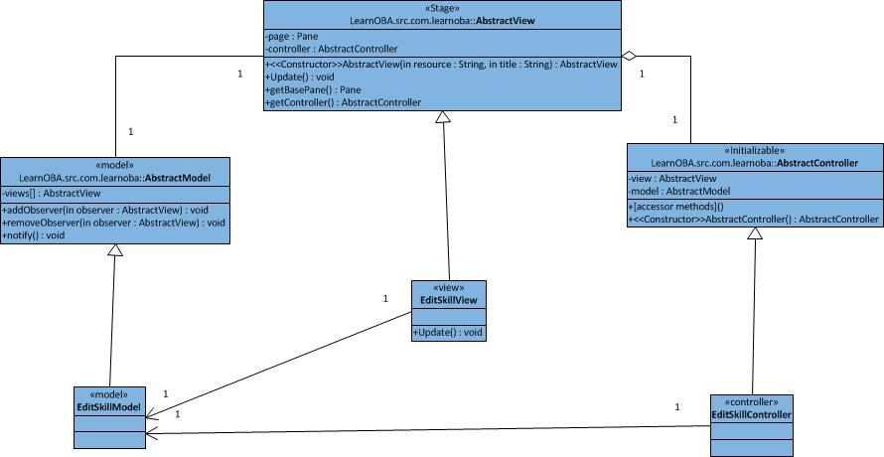

Figure - Edit Skill Model View Controller

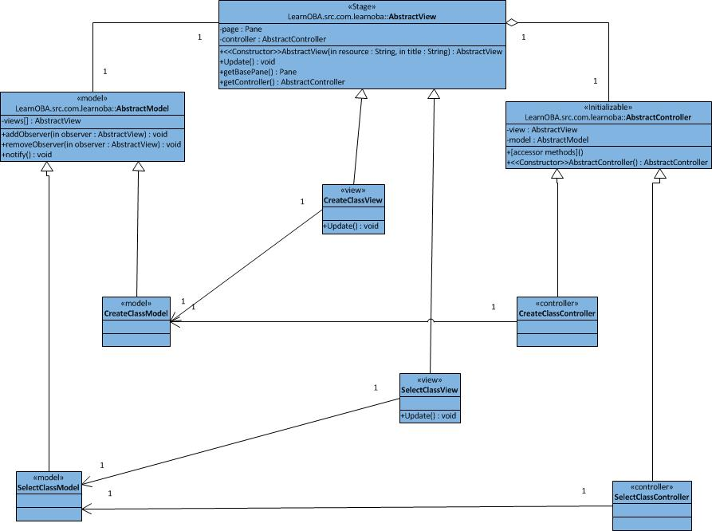

Figure - Class Model View Controller

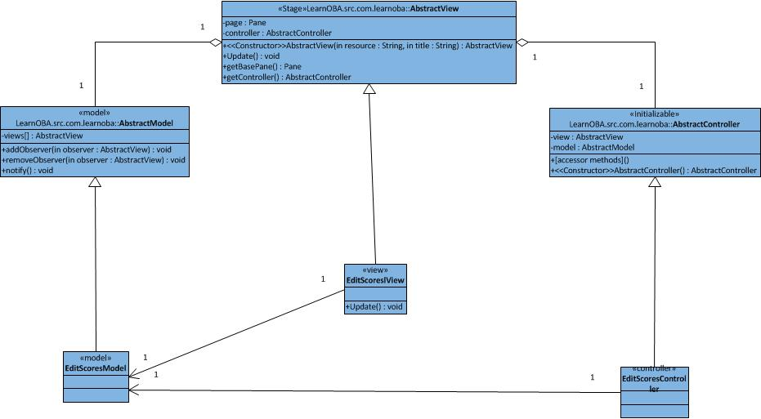

Figure - Edit Scores Model View Controller

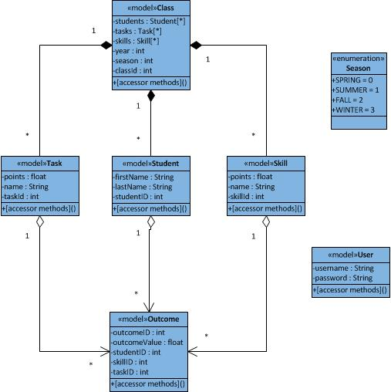

Figure - Database Object Java Models

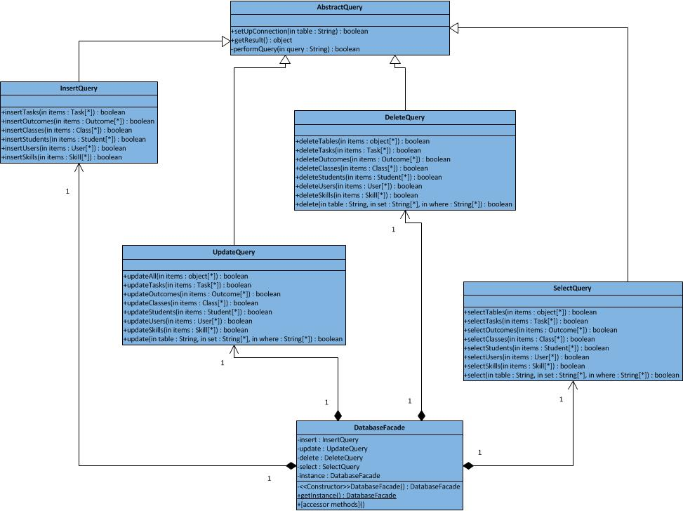

Figure - Database Facade (Object Relational Mapping Component)